**POWER INVESTIGATION REPORT**

1. **Power Usage Investigation**
   1. **Abstract**

This investigation is based on data collected from a power meter of a house which contains information on date, time and the units shown on the meter.

We will observe when are the highest and the lowest usage rates, any patterns found in the usage of electricity in the week and based on the data we will be able to interpret about the factors effecting power usage units, or any external factors involved.

* 1. **Background**

The Purpose of this Investigation is to understand if we can infer from the data about the relation between the day of week and consumption of electricity in the house.

We will consider day of week as a parameter since we know usually families go for an outing during the weekends and stay in during the weekdays which might affect the readings in power meter. Based on this assumption we will do some analysis and plot the power usage across days of the week.

* 1. **Methodology**

The input data consists of datetime and meter readings in the csv file. Looking at the data, it appeared to be a time series, we will choose to check how the pattern with time appears, so for that, we first clean the data and bring the datetime to proper format for plotting.

The format chosen is: **%d-%m-%Y %H:%M:%S**

The data in the dataframe appears to be like this:

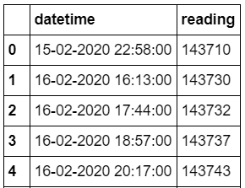

Now, when plotted the datetime vs meter readings, we see that there is a constant increase in the graph which is obvious, but we saw some flat lines, some straight lines, and some curves.

The plot produced by the datetime vs meter reading is as follows:

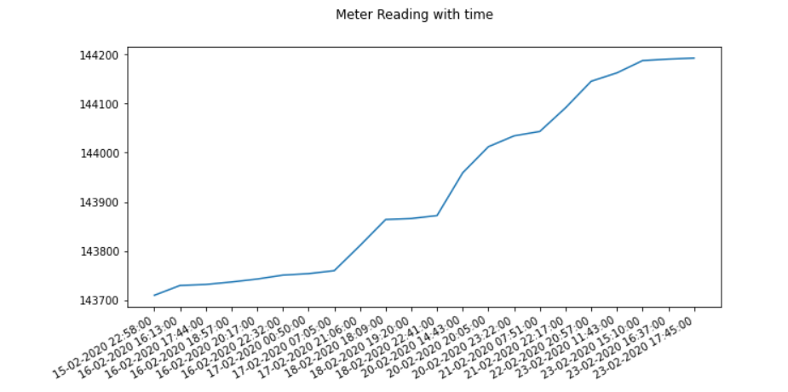

This gives us a high-level idea of the power usage on which we can build some hypothesis based on these ups and downs and then aggregate the units for each day to investigate the pattern that can be found across the week.

For aggregation, we use simple calculations:

**Power Units for the day = (Max meter reading for the day – Max meter reading for previous day)**

By this, we simplify our data to sum up the power units for the day removing the time component from datetime and then also find the day of week from the date, data looks like this in the dataframe:

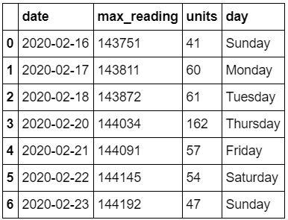

Based on this information, we can build some plots to verify our hypothesis.

* 1. **Results**

Based on the meter reading vs day, we see that there is a constant usage of power in the house, which is obvious, however when plotting power unit’s vs date, we see that there is a spike in some days than the rest.

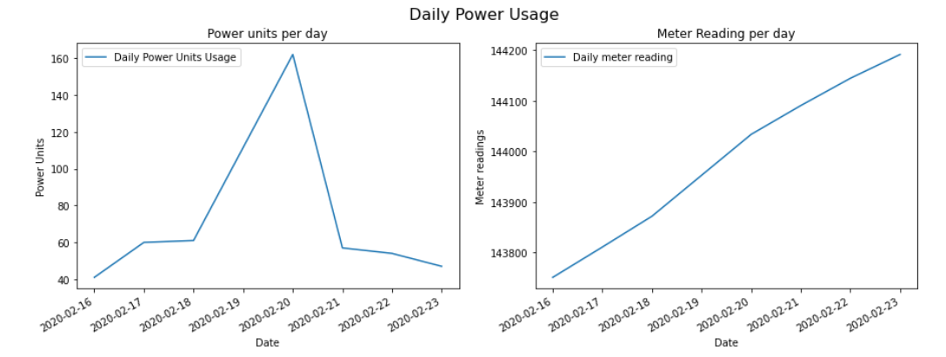

Plotting Day of week vs Power meter readings help us to know that the usage was high during the middle of the week. However, the weekends remained at lower level.

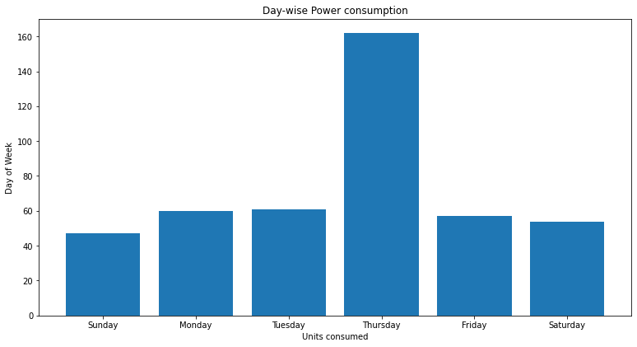

* 1. **Conclusion**

As we started with the hypothesis, that people usually go for family outings to relax and spend more time with each other, so they may not be using electricity compared to what they use during the weekdays.

Although, people might go to offices during the weekdays, but the use of appliances might be more during weekdays since after long day work, they would eventually use those appliances. Another factor might be the number of people in the house, people would more members would suggest more children and their individual gadgets/ consoles which would contribute to the power usage.

For these assumptions, we may need to drill down to these power units and carry out with second investigation which gives a clear idea, how a normal day looks like in a house, the usage of appliances and their power ratings.

* 1. **References**
     1. <https://pandas.pydata.org/pandas-docs/version/0.17.0/generated/pandas.DataFrame.plot.html>
     2. <https://www.tutorialspoint.com/matplotlib/index.htm>

1. **Power Modelling Investigation**
   1. **Abstract**

This investigation is based on the hourly usage of appliances in the house and their power rating. We will see what how usage of each appliance impact total power consumption in the house.

We will also introduce a new factor, rate of solar and electricity and then use in our model to compare the rates of power consumption in the house.

* 1. **Background**

The purpose of this investigation is to identify the appliances which have major impact on power consumption in the house.

Also, if the usage hours, or power units of appliances impact the power consumption. We will also introduce pricing of solar and compare how our costs would look with solar vs electricity with current run rate of appliances.   
We will consider two parameters – hourly usage and power rating of appliances for our analysis, since based on these, we can calculate power consumption by the formula:

Power Consumption (in kWh) = power rating (in W) x usage (in hrs) / 1000

We will also introduce rate parameter for both solar and electricity by which we can see the differences in the prices paid by the house Annually and the savings they can make if they opt for Solar as alternative power source.

* 1. **Methodology**

The input data is a summary of power usage in the house for a day, which consists of all the appliances in the house, for how long they are used, tracking usage for each hour of the day, and also, the power rating of the appliance (in W).

The data format is not a csv, or any importable format for a pandas dataframe, so we do some cleaning before importing in dataframe. Our cleaned data looks something like this:

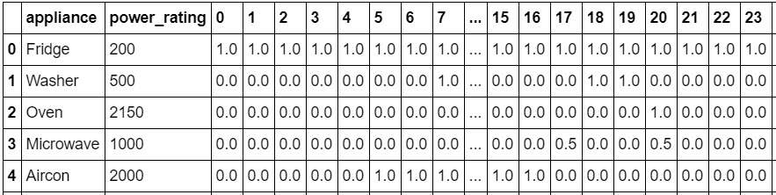

The columns appliance and power ratings implicitly indicate appliances in the house and their power rating (in W). The numbered columns 0-23 denotes each hour of the data and the values denotes for how many hours those appliances ran.

Based on this information, we plan to calculate the power consumption for each appliance for that day. We sum up the total hours across each hour and based on the formula above, we calculate a new column for power consumption.

Now our data looks like this:

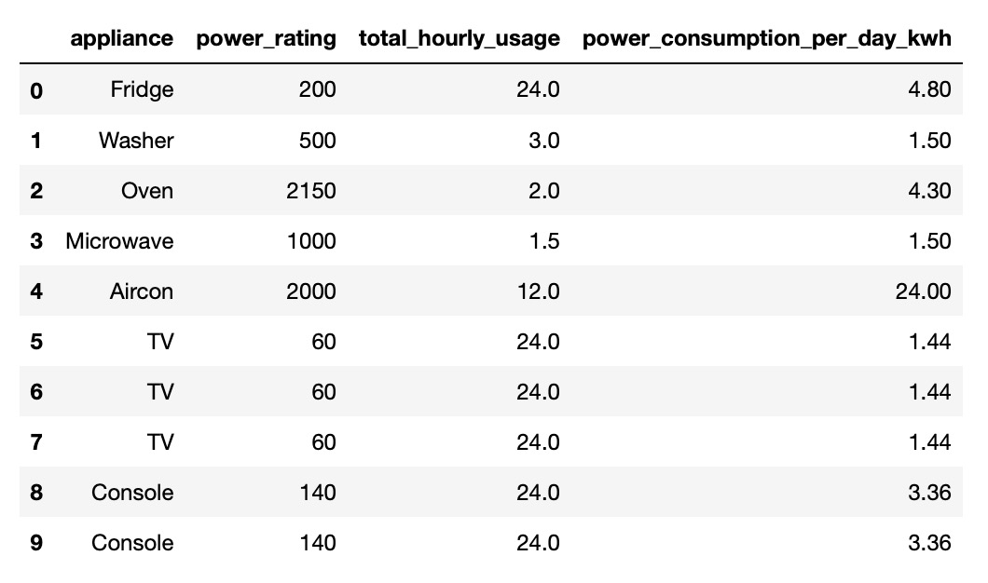

Now, based on these values, it is easier for us to plot graphs for hourly usage per appliance and power consumption per appliance.

* 1. **Results**

Here are the subplots for the above information:

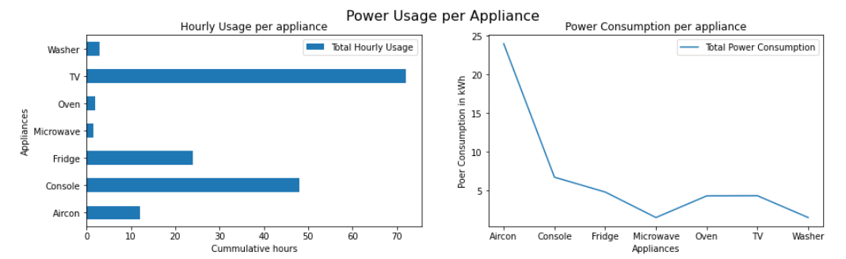

As we see from above graphs and data that there are three televisions, two consoles and fridge that are running 24 hours a day, which obviously contribute the power consumption in the house, as in the left sub-plot.

However, when we look closely to the right sub-plot, we see that the power consumption of those appliances is not much as compared to Aircon. Aircon was used only for 12 hours but its power rating is high which consumes more electricity.

Then, we introduce two rates, for solar power and electricity and then compare the annual rates based considering the data as average consumption of the house.

The rates are from external sources:

Solar Price in USD = 0.085 per kWh

Electricity Price in USD = 0.14 per kWh

Based on the annual rates, we then plot Annual price for Solar Power and Electricity for each appliance:

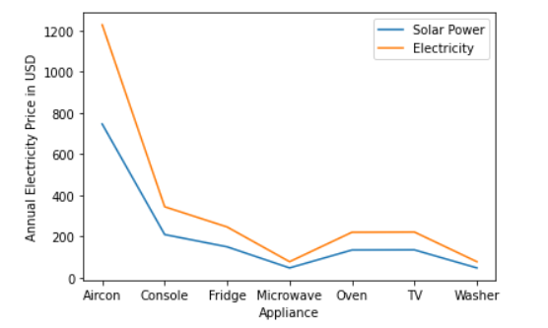

* 1. **Conclusion**

Based on our model, we saw that the Aircon consumed more electricity that any other appliance even though it ran for only 12 few hours as compared to TV which ran collectively for 72 hours. This was due to the high-power rating of Aircon.

Based on our previous investigation, we also saw that weekends show lower power usage. This result might add up to our previous conclusion that when family go for outings during the weekends, they tend to switch off their appliances like Aircon, TV, consoles. Fridge might not impact as it should be running 24 hours a day even if there is no individual in the house.

Apart from this, we also saw that Aircon contributes to more than 1200 USD for electricity in a year for the house, however, when switching to Solar power, it costs less than 800 USD. There would be a huge savings if the house is completely solar powered. Not only aircon, this saving is for any other appliances which is switched to solar power.

However, if the house is in the locality, there are some factors, which have to be considered when planning to switch to Solar power like feasibility of solar provider to put solar panels for individual home or whole locality, also if climatic changes or weather would impact solar powered electricity in the house, and if there are options by electricity provider for greater good of both. For these, we may need to investigate further for the whole locality so that the electricity provider can build some plans looking at the usage of all the houses in the locality and act accordingly.

* 1. **References**
     1. <https://pandas.pydata.org/pandas-docs/version/0.17.0/visualization.html>
     2. <https://www.tutorialspoint.com/matplotlib/index.htm>
     3. <https://www.energuide.be/en/questions-answers/how-can-i-calculate-the-consumption-of-an-electrical-appliance/94/>
     4. <https://www.electricchoice.com/electricity-prices-by-state/>

1. **Power simulation Investigation**
   1. **Abstract**

This investigation is based on multiple files as in Power Modelling investigation but for multiple houses in the locality. We will see how these appliances with different power ratings and different hourly usage in each house impacts usage of electricity in that locality.

We will also consider solar energy as an alternative source and how it would help both electricity provider for load balancing and house owners to get electrical energy in their houses at cheaper prices. Also considering various factors, if there is any way in which people get power in dual mode.

* 1. **Background**

The purpose of this investigation is to compare and analyze power usage of electricity in a locality.

We will be able to see how solar power will benefit the locality in terms of annual charges they pay for electricity if solar power is introduced in their locality.

We will also look with the perspective of electricity providers that how loads can be reduced, and to ensure that there is a balanced distribution of electricity in the locality. Also, how tie up with solar providers would attract people by bringing up plans like dual mode power since there are many factors that would result in less effective solar power like the climatic conditions.

* 1. **Methodology**

The input data is a summary of power usage in all the house in the locality for the day, which consists of all the appliances in the house, for how long they are used, tracking usage for each hour of the day, and also, the power rating of the appliance (in W). There is one more information in the file i.e. house number.

The data format is not a csv, or any importable format for a pandas dataframe, so we do some cleaning before importing in dataframe. Our cleaned data looks like what we have in out previous investigation but for multiple houses with a new column added for house number.

The data looks like this:

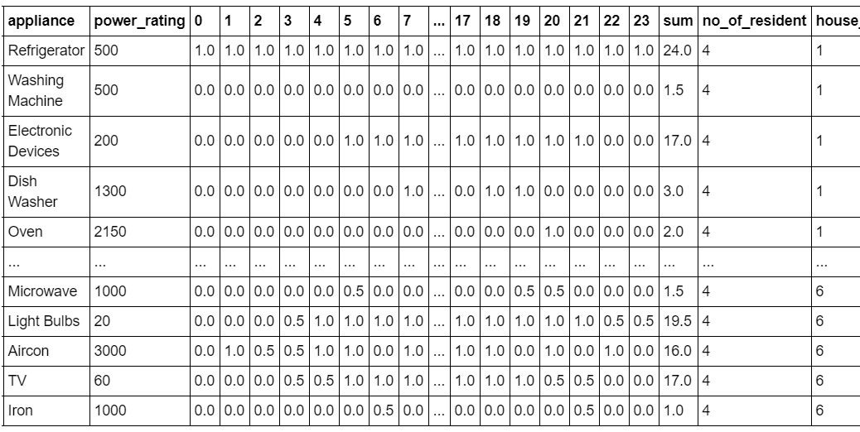

From the above data, we see the hourly usage of each appliance for each house and a total of usage hours, and from this we can create subplots for each house and see if there is any variation of hourly usage of appliances in all the houses of the locality.

Here are the subplots for the above data:

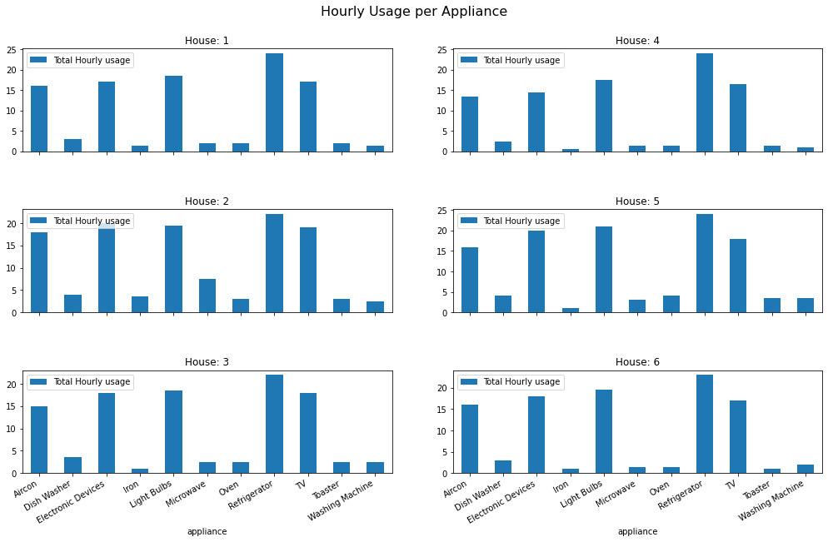

From the above graphs, we see that almost all the houses have same patterns of using their appliances. This gives an idea to the electricity provider, that which hour of the day would add to the power load, and which house consumes more electricity. Based on this, the electricity provide can bring up plans like dynamic rates for each hour so that there is balanced load and no shortage of electricity in the locality.

* 1. **Results**

Then, we introduce two rates, for solar power and electricity and then compare the annual rates based considering the data as average consumption of each house.

The rates are from external sources:

Solar Price in USD = 0.085 per kWh

Electricity Price in USD = 0.14 per kWh

Based on the annual rates, we then plot Annual price for Solar Power and Electricity for each house:

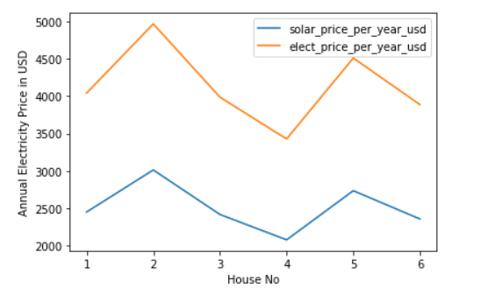

* 1. **Conclusion**

Based on our model, we saw that if the electricity is replaced with solar power, all the houses in the locality can save up to 40% of the costs they are paying annually for the electricity. This is huge savings for any house in the locality.

Apart from this we also saw that all the houses in the locality have similar pattern in how they consume their appliances. The electricity provider can plan to take a decision if people in the locality are interested to switch to Solar power.

The electricity consumption will obviously not be 100% reduced, due to various factors, like weather as solar may not function efficiently during monsoon but a fusion of both can be a solution. So, provider can decide to bring up plans to supply power in dual mode and revise the charges accordingly.   
And since it would be feasible for the provider to setup for whole locality as large scale solar panels than to setup at individual houses, they can communicate regarding this with the society manger or people of the locality.

* 1. **References**
     1. <https://pandas.pydata.org/pandas-docs/version/0.17.0/generated/pandas.DataFrame.plot.html>
     2. <https://pandas.pydata.org/pandas-docs/version/0.17.0/visualization.html>
     3. <https://www.tutorialspoint.com/matplotlib/index.htm>
     4. <https://www.energuide.be/en/questions-answers/how-can-i-calculate-the-consumption-of-an-electrical-appliance/94/>
     5. <https://www.electricchoice.com/electricity-prices-by-state>